

Practices for Secure Software Report

Table of Contents
Document Revision History 3
Client 3
Instructions 3
Developer 4
1. Algorithm Cipher 4
2. Certificate Generation 4
3. Deploy Cipher 4
4. Secure Communications 4
5. Secondary Testing 4
6. Functional Testing 4
7. Summary 4
8. Industry Standard Best Practices 4

Document Revision History

Version | Date | Author | Comments
1.0 | 8/16/26 | Eric Sawyer

Client



Developer
Eric Sawyer

Algorithm Cipher
My recommended algorithm for this application is SHA-256 for the checksum and hash verification process. SHA-256 is a secure and widely accepted hash function in the SHA-2 family. Also, it produces a 256-bit digest which offers strong collision resistance and is suitable for verifying file integrity and data authenticity in a web application. The project uses HTTPS/TLS for secure communications, while the hash route verifies the integrity of the transmitted data before it is accepted as valid. This combination provides confidentiality and integrity protection for the data transfer workflow.

SHA-256 supports modern cryptographic use cases and is broadly trusted in government, financial, and enterprise systems. It is preferred over weaker algorithms because it resists brute-force and collision attacks better than older hash functions like MD5 and SHA-1. Random numbers are important in certificate and key generation, and the application uses a self-signed PKCS12 keystore generated with the Java keytool. This preserves the confidentiality of the TLS channel and enables symmetric encryption over HTTPS using the TLS protocol. The TLS process uses asymmetric key exchange to establish a session and symmetric session keys to encrypt the communication stream.

The history of secure encryption continues to evolve from symmetric specifications such as DES and AES to stronger public-key techniques and modern hash algorithms. SHA-256 remains a current and recommended standard because it is recognized internationally and widely supported in Java and modern browsers.

Certificate Generation
The project generated a self-signed certificate using Java keytool. The alias used was artemisfinancial, and the keystore type was PKCS12. The resulting certificate was exported to src/main/resources/artemis-financial.cer.
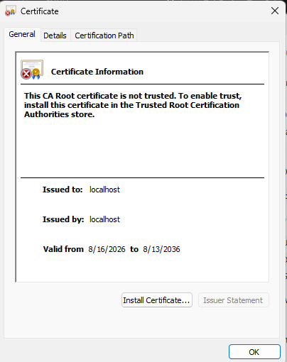

Deploy Cipher
The application implements a /hash endpoint that returns a checksum for a unique data string created for this assignment. The stored data is then hashed using SHA-256, allowing the application to verify integrity without exposing the original plain text content in the response.
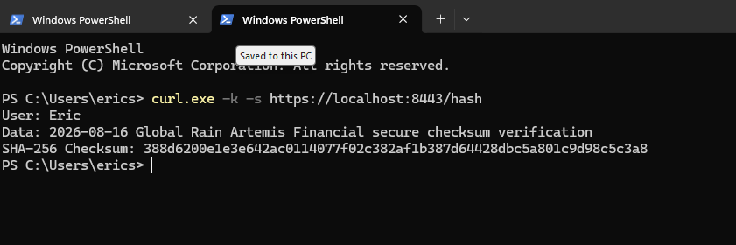

Secure Communications
The application was refactored to run on HTTPS by setting the server port to 8443 and configuring a PKCS12 keystore in src/main/resources/application.properties.
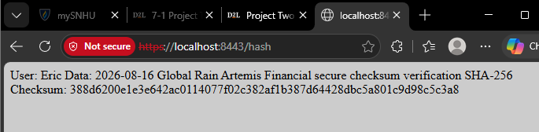

Secondary Testing
A secondary static test was performed with OWASP Dependency-Check. 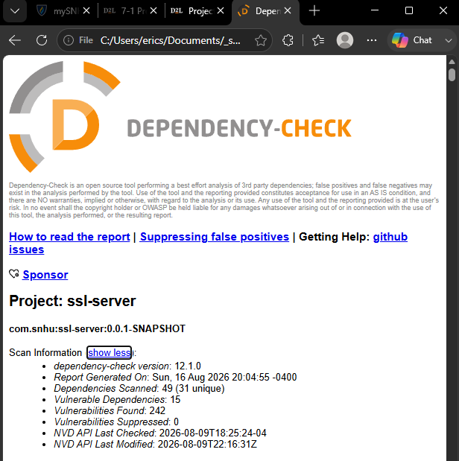

Functional Testing
Insert a screenshot below of the refactored code executed without errors.
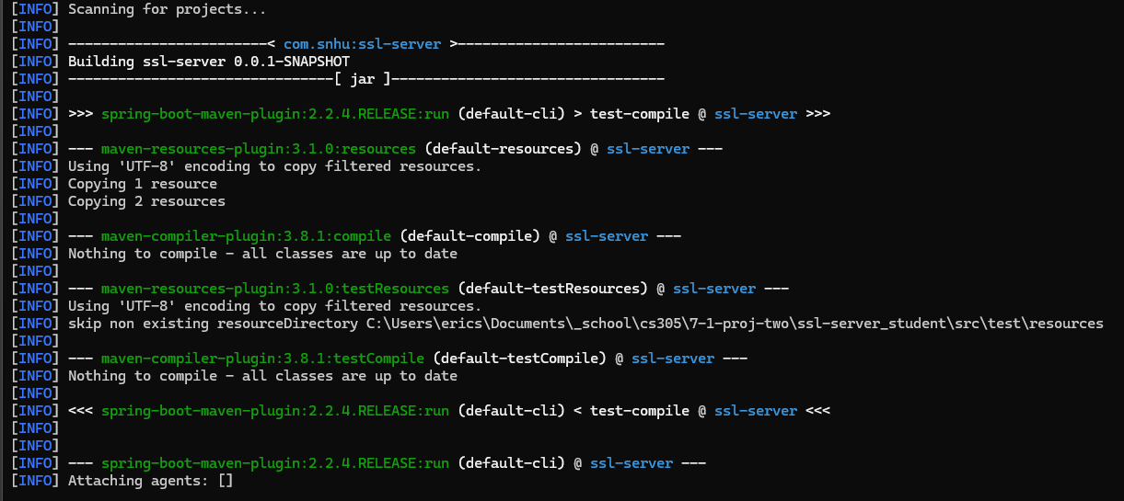

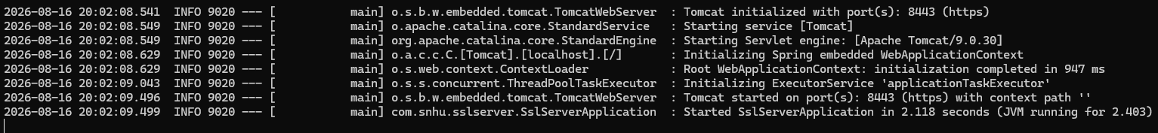

Summary
This project adds multiple additional layers of security to Artemis Financial’s application. This implementation uses HTTPS instead of HTTP, enforces TLS with a self-signed certificate, and includes a checksum verification endpoint using SHA-256. These changes directly address the client’s request for secure communication and data verification. The project follows safe patterns for secure software design, including guided key management, standardized hash use, and explicit validation through an integrity endpoint. The application’s security posture was improved by replacing insecure transmission assumptions with encrypted HTTPS transport, protecting data in transit, and verifying integrity through a checksum. These practices align with industry standard secure coding guidance and reduce operational risk for the organization.

Industry Standard Best Practices
The best industry practices applied included the use of current encryption standards, storing certificate material in the project resources, using PKCS12 for interoperability, avoiding deprecated algorithms, and verifying integrity through hash outputs. These steps work together to protect the company’s financial data and support easy long-term secure software maintenance.

